Homework 4

# 1. Prove: diam(G) ≤ 2rad(G)

The idea is from center point.

For each graph G, extract the path of where diameter comes from. For example, for the path A… E…Z which is a diameter, and E is the center point.

The size of AE and EZ will be less or equal than the radius, which means AE+EZ<=2*radius.

So, we find the statement: diameter <= 2*radius.

# 2. Find 3-cycles and 4-cycles in a planar graph:

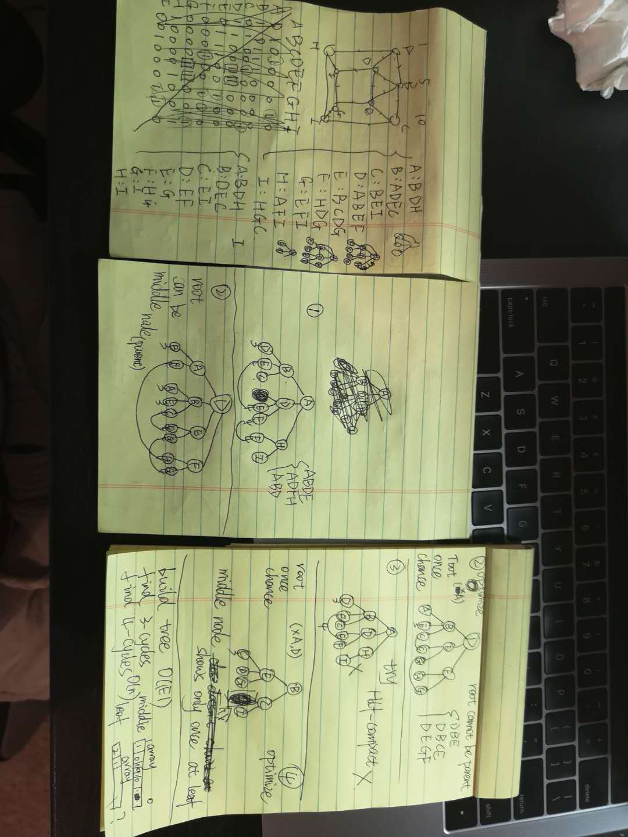

1. Planar graph example shows on the left demo.

2. Use adjacency list to represent the whole graph.

3. Generate a 3-level tree structure for each vertex, following two rules:

1. if a vertex has been root, then doesn’t show at the middle level;

2. if a vertex has already shown (had children) at the middle level, then doesn’t show as a leaf. For example, on the middle demo, step 1, B can have D, but D can’t have B; and on the right demo, E can have C, but C can’t have E.

4. Use three arrays with same size (number of vertices) to find cycles:

1. bool array for middle level vertices;

2. integer array for leaves;

3. array storing list for leaves parents; (if value in the integer array equals 2)

5. Find 3-cycles: Compare the same index from bool array and integer array, if there are true and 1, then find a 3-cycle.

6. Find 4-cycles: retrieve integer array, if there is a value 2, then find a 4-cycle.

Question: I’m not sure for the integer array, which there could be odd values more than 1, or even values more than 2. However, I can fix this problem based on this algorithm.

Problem of these constrains. Lost one 4-cycle

